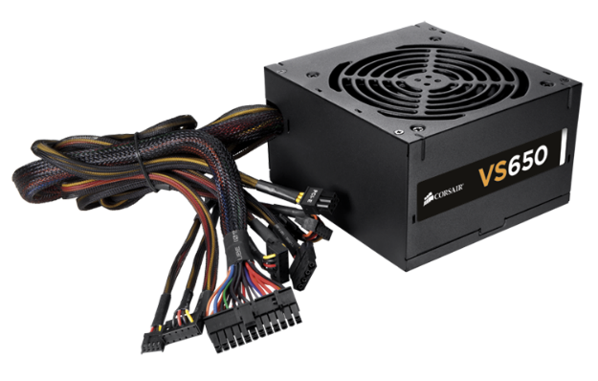
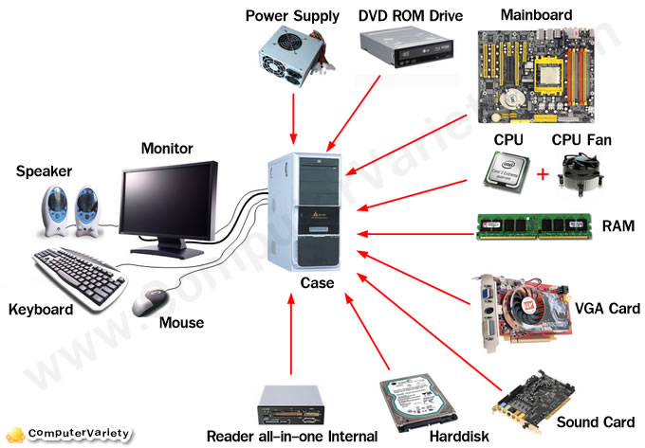
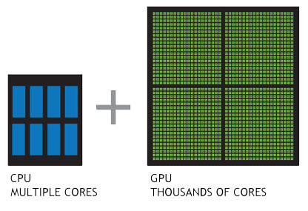
The mainboard is the main hub for physically storing the cpu, ram , sound card in the case. It is the control circuit on how

The power supply does what it says it give computers power. This one has a fan because they get to hot.

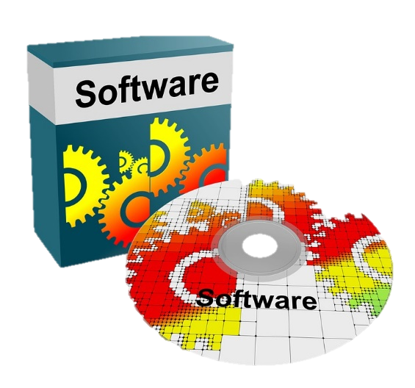

Software

Software is usually stored on disc but nowadays it is online as a download which makes the internet bandwidth really slow.
Software on a disc is really expensive compare to the internet version.
Because of this people just use the internet and use a product key to verify that is has been paid for. This allows the users to share the key online so that others can use it. Although it is illeagal people still do it unfortunately.

